CE221-L Digital Logic Design Lab



Lab report # 08

Submitted by: Shayan Rizwan
Registration Number: 2024585
Submitted to: Engr. Irfanullah
Semester: 03

Faculty of Computer Science and Engineering
GIK Institute of Engineering Sciences and Technology

Task Statement:
Design a full adder using Behavioral modeling in Verilog, write test benches to verify its functionality, and simulate to visualize the waveforms and show its RTL.
Solution
CODE:
module full_adder(a,b,c,carry,sum );
input a,b,c;
output sum,carry;
reg sum,carry;
always@( a or b or c)
begin
sum = a^b^c;
carry = (a&b) | c & (a^b);
end
endmodule
Test Bench:
` module full_adder_tb();
// Inputs
reg a;
reg b;
reg c;
// Outputs
wire sum;
wire carry;
full_adder uut(.sum(sum),.carry(carry),.a(a),.b(b),.c(c));
initial
begin
a = 0; b = 0; c=0;
#10 a = 0; b = 0; c=1;
#10 a = 0; b = 1; c=0;
#10 a = 0; b = 1; c=1;
#10 a = 1; b = 0; c=0;
#10 a = 1; b = 0; c=1;
#10 a = 1; b = 1; c=0;
#10 a = 1; b = 1; c=1;
$finish;
end
endmodule
RTL:
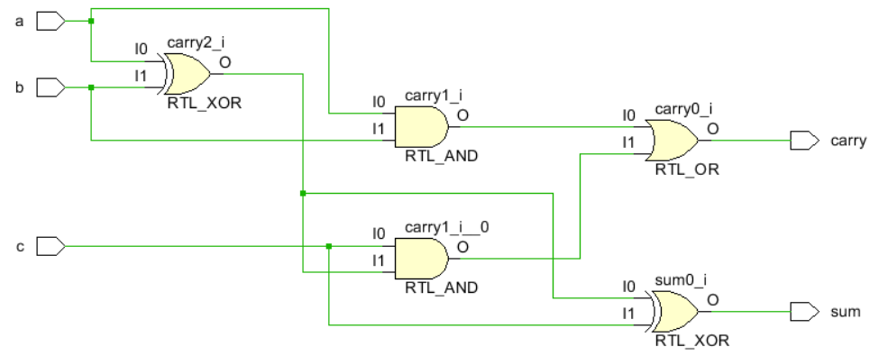

Output:
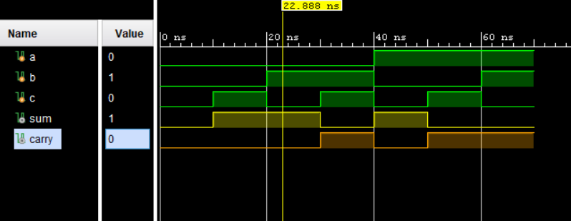

Task Statement:
Design a 4x1 Multiplexer using Behavioral modeling in Verilog, write test benches to verify its functionality, and simulate to visualize the waveforms and show its RTL.
Solution
Code
module mux_4x1(y,i,s);
output y;
input [3:0]i;
input [1:0]s;
reg y;
// Behavioural
always@(i or s)
// Using case statement
case(s)
3'b00:y = i[0];
3'b01:y = i[1];
3'b10:y = i[2];
3'b11:y = i[3];
default: y = 1'b0;
endcase
endmodule
Test Bench
module mux_4x1_tb();
// Inputs
reg [3:0] i;
reg [1:0] s;
// Outputs
wire y;
// Instantiate the Unit Under Test (UUT)
mux_8x1 uut ( .y(y),.i(i),.s(s));
initial
begin
// Initialize Inputs

i = 4'b1010;
s = 2'b00; #10;
s = 2'b01; #10;
s = 2'b10; #10;
s = 2'b11; #10;

i= 4'b1100;
s = 2'b00; #10;
s = 2'b01; #10;
s = 2'b10; #10;
s = 2'b11; #10;

i = 4'b0110;
s = 2'b00; #10;
s = 2'b01; #10;
s = 2'b10; #10;
s = 2'b11; #10;

i = 4'b1001;
s = 2'b00; #10;
s = 2'b01; #10;
s = 2'b10; #10;
s = 2'b11; #10;

i = 4'b1111;
s = 2'b00; #10;
s = 2'b01; #10;
s = 2'b10; #10;
s = 2'b11; #10;

i = 4'b0000;
s = 2'b00; #10;
s = 2'b01; #10;
s = 2'b10; #10;
s = 2'b11; #10;
$finish;
end
endmodule
RTL
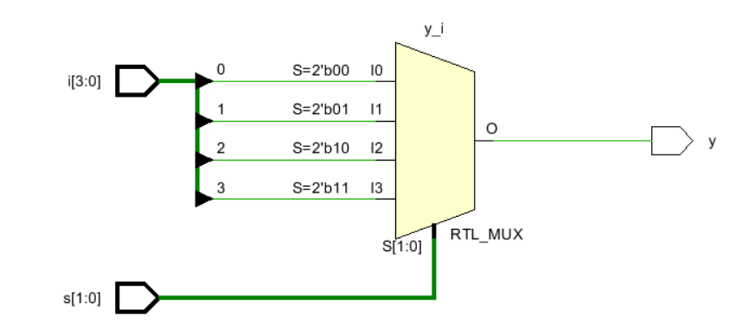

Output
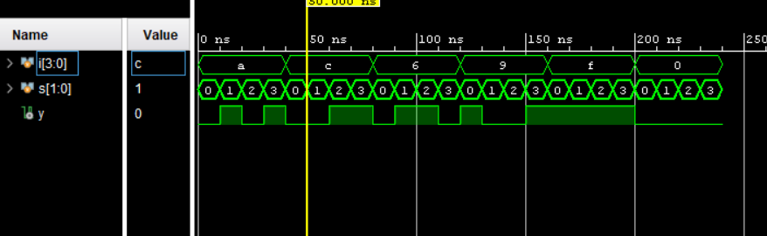

Task Statement:
Design a 3x8 Decoder using Behavioral modeling in Verilog, write test benches to verify its functionality, and simulate to visualize the waveforms and show its RTL.
Solution
CODE:
module decoder_3x8(input [2:0] a,output reg [7:0] out,input en);
always @(*)
begin
if (en)
case(a)
3'b000: out = 8'b00000001;
3'b001: out = 8'b00000010;
3'b010: out = 8'b00000100;
3'b011: out = 8'b00001000;
3'b100: out = 8'b00010000;
3'b101: out = 8'b00100000;
3'b110: out = 8'b01000000;
3'b111: out = 8'b10000000;
default: out = 8'b00000000;
endcase
else
out = 8'b00000000;
end
endmodule
Test Bench:
module deocoder_3x8_tb();
reg [2:0] a;
reg en;
wire [7:0] out;
decoder_3x8 uut(.a(a),.en(en),.out(out));
initial
begin
$monitor($time, " a=%b, en=%b, out=%b", a, en, out);
en = 0;
a = 3'b000; #10;
a = 3'b001; #10;
a = 3'b010; #10;
a = 3'b011; #10;
a = 3'b100; #10;
a = 3'b101; #10;
a = 3'b110; #10;
a = 3'b111; #10;

en = 1;
a = 3'b000; #10;
a = 3'b001; #10;
a = 3'b010; #10;
a = 3'b011; #10;
a = 3'b101; #10;
a = 3'b100; #10;
a = 3'b110; #10;
a = 3'b111; #10;
$finish;
end
endmodule

RTL:
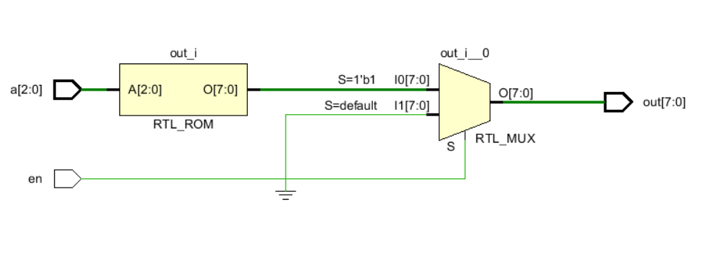
Output:
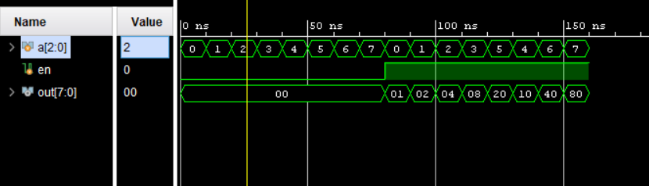

Task Statement:
Design an ALU using Behavioral modeling in Verilog, write test benches to verify its functionality, and simulate to visualize the waveforms and show its RTL.
Solution

Code:
module ALU(input [8:0] a,input [8:0] b,input [3:0] sel,output reg [8:0] c);
always @(*)
begin
case(sel)
4'b0000: c = a+b;
4'b0001: c = a-b;
4'b0010: c = a*b;
4'b0011: c = a&&b;
4'b0100: c = a||b;
4'b0101: c = a&b;
4'b0100: c = a|b;
4'b0111: c = a<<1;
4'b1000: c = a>>b;
4'b1001: c = ~a;
4'b1010: c = !a;
4'b1011: c = a+1;
4'b1100: c = a-1;
4'b1101: c = b+1;
4'b1110: c = b-1;
4'b1111: c = b;
endcase
end
endmodule

Test Bench:
module ALU_tb();
reg [8:0] a;
reg [8:0] b;
reg [3:0] sel;
wire [8:0] c;
ALU uut (.c(c),.a(a),.b(b),.sel(sel));
initial
begin
a = 1;b = 1; sel = 4'b0000;
#10 a = 1;b = 0; sel = 4'b0001;
#10 a = 1;b = 1; sel = 4'b0010;
#10 a = 1;b = 1; sel = 4'b0011;
#10 a = 0;b = 1; sel = 4'b0100;
#10 a = 1;b = 0; sel = 4'b0101;
#10 a = 1;b = 1; sel = 4'b0110;
#10 a = 1;b = 1; sel = 4'b0111;
#10 a = 1;b = 1; sel = 4'b1000;
#10 a = 0;b = 1; sel = 4'b1001;
#10 a = 1;b = 0; sel = 4'b1010;
#10 a = 1;b = 1; sel = 4'b1011;
#10 a = 1;b = 0; sel = 4'b1100;
#10 a = 0;b = 0; sel = 4'b1101;
#10 a = 0;b = 1; sel = 4'b1110;
#10 a = 0;b = 0; sel = 4'b1111;
#10
$finish;
end
endmodule

RTL
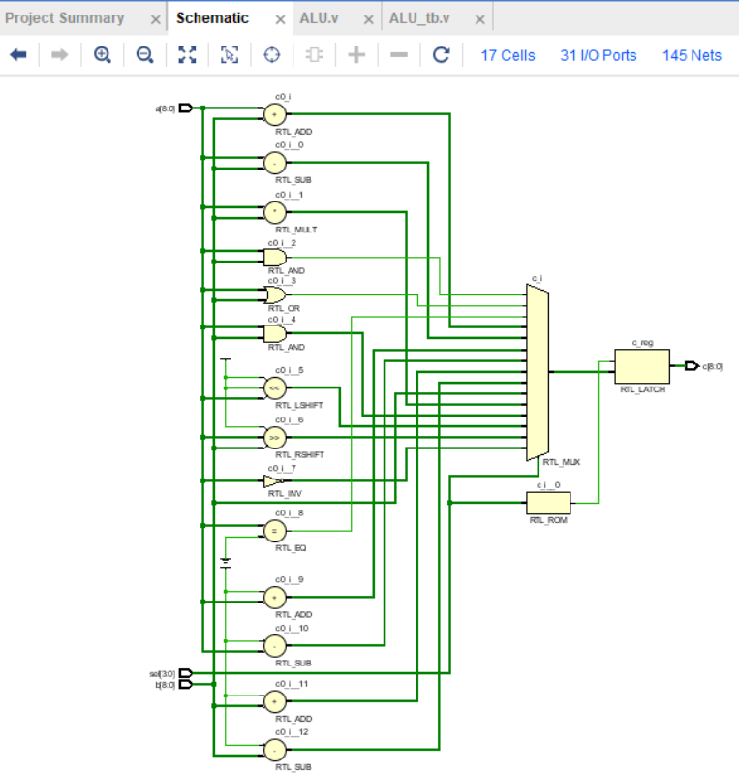
Output
